1. Group Anagrams :
#CODE:
import java.util.*;

class Solution {
public List<List<String>> groupAnagrams(String[] strs) {

HashMap<String, List<String>> map = new HashMap<>();

for (String str : strs) {

char[] chars = str.toCharArray();
Arrays.sort(chars);

String key = new String(chars);

if (!map.containsKey(key)) {
map.put(key, new ArrayList<>());
}

map.get(key).add(str);
}

return new ArrayList<>(map.values());
}
}

OUTPUT:
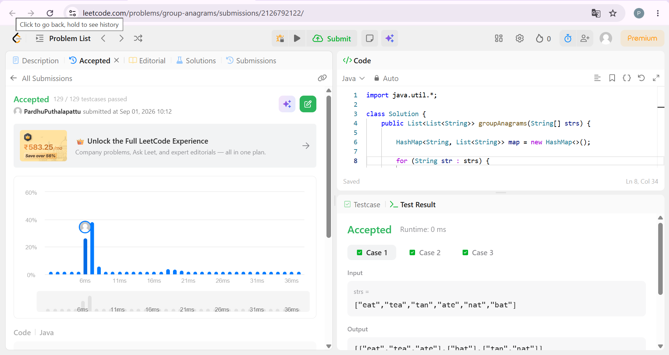

2. Top K Frequent Elements :
#CODE:
import java.util.*;

class Solution {
public int[] topKFrequent(int[] nums, int k) {

// Count frequency of each number
HashMap<Integer, Integer> map = new HashMap<>();

for (int num : nums) {
map.put(num, map.getOrDefault(num, 0) + 1);
}

// Min Heap based on frequency
PriorityQueue<Integer> pq = new PriorityQueue<>(
(a, b) -> map.get(a) - map.get(b)
);

// Keep only k most frequent elements
for (int num : map.keySet()) {
pq.add(num);

if (pq.size() > k) {
pq.poll();
}
}

// Store result
int[] ans = new int[k];

for (int i = 0; i < k; i++) {
ans[i] = pq.poll();
}

return ans;
}
}
OUTPUT: